Crypto Wallet
# Source: AI Source: Provided by: [Data Path: Persons Table -> ID Column: 1, Name_En Column: Motasem Essam] -> From: [ChatGPT] on [1/21/2026]
A Crypto Wallet is a type of digital wallet used to store, send, receive, and manage cryptocurrencies such as Bitcoin (BTC), Ethereum (ETH), and other digital assets. Unlike traditional wallets that store fiat currency, a crypto wallet stores private and public keys used to access and control crypto on the blockchain.

✅ Key Characteristics of Crypto Wallets:
# Source: AI Source: Provided by: [Data Path: Persons Table -> ID Column: 1, Name_En Column: Motasem Essam] -> From: [ChatGPT] on [1/21/2026]
- Key-Based System
  - Stores private keys (used to sign transactions) and public keys (used to receive funds).
  - Ownership of cryptocurrency is determined by control of private keys.
- Wallet Types: Custodial vs Non-Custodial
  - Custodial Wallet: A third party (like an exchange) holds the private keys (e.g., Binance Wallet).
  - Non-Custodial Wallet: The user controls their private keys (e.g., MetaMask, Trust Wallet).
- Supports Multiple Assets
  - Many wallets support a range of tokens across different blockchains (e.g., ETH, ERC-20, BTC, BNB).
- Blockchain Interaction
  - Used to sign and broadcast transactions to blockchain networks.

📦 Types of Crypto Wallets (by Storage Method):
# Source: AI Source: Provided by: [Data Path: Persons Table -> ID Column: 1, Name_En Column: Motasem Essam] -> From: [ChatGPT] on [1/21/2026]
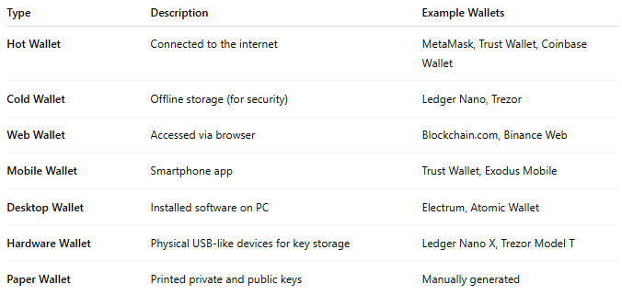

Type | Description | Example Wallets
Hot Wallet | Connected to the internet | MetaMask, Trust Wallet, Coinbase Wallet
Cold Wallet | Offline storage (for security) | Ledger Nano, Trezor
Web Wallet | Accessed via browser | Blockchain.com, Binance Web
Mobile Wallet | Smartphone app | Trust Wallet, Exodus Mobile
Desktop Wallet | Installed software on PC | Electrum, Atomic Wallet
Hardware Wallet | Physical USB-like devices for key storage | Ledger Nano X, Trezor Model T
Paper Wallet | Printed private and public keys | Manually generated

🔄 How It Works:
# Source: AI Source: Provided by: [Data Path: Persons Table -> ID Column: 1, Name_En Column: Motasem Essam] -> From: [ChatGPT] on [1/21/2026]
- Wallet Generates Key Pair
  - A public key (address) and a private key are created.
- User receives crypto to their public address.
- To send funds, the wallet uses the private key to sign the transaction.
- The transaction is broadcast to the blockchain network for validation and inclusion.

✅ Advantages:
# Source: AI Source: Provided by: [Data Path: Persons Table -> ID Column: 1, Name_En Column: Motasem Essam] -> From: [ChatGPT] on [1/21/2026]
- Full control of assets (in non-custodial wallets)
- Supports global, borderless payments
- Can interact with Web3 apps, DeFi, NFTs, and DApps
- Highly secure when using cold storage

⚠️ Challenges:
# Source: AI Source: Provided by: [Data Path: Persons Table -> ID Column: 1, Name_En Column: Motasem Essam] -> From: [ChatGPT] on [1/21/2026]
- Loss of private key = loss of funds (irreversible)
- Phishing and malware threats (especially for hot wallets)
- Not reversible – transactions are permanent once confirmed
- User must understand blockchain basics for safe use

🆚 Compared with Other Wallet Types:
# Source: AI Source: Provided by: [Data Path: Persons Table -> ID Column: 1, Name_En Column: Motasem Essam] -> From: [ChatGPT] on [1/21/2026]
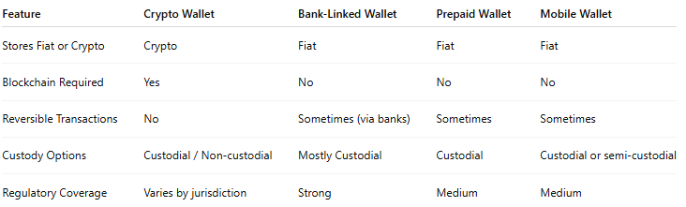

Feature | Crypto Wallet | Bank-Linked Wallet | Prepaid Wallet | Mobile Wallet
Stores Fiat or Crypto | Crypto | Fiat | Fiat | Fiat
Blockchain Required | Yes | No | No | No
Reversible Transactions | No | Sometimes (via banks) | Sometimes | Sometimes
Custody Options | Custodial / Non-custodial | Mostly Custodial | Custodial | Custodial or semi-custodial
Regulatory Coverage | Varies by jurisdiction | Strong | Medium | Medium

🔐 Security Tips for Crypto Wallets:
# Source: AI Source: Provided by: [Data Path: Persons Table -> ID Column: 1, Name_En Column: Motasem Essam] -> From: [ChatGPT] on [1/21/2026]
- Use hardware wallets for large holdings
- Enable 2FA and strong passwords
- Never share or expose your private key or seed phrase
- Back up your seed phrase and store it offline
- Double-check wallet addresses before sending

